# **Qualitative and quantitative data**

**Quantitative data** is the type of **data** whose value is measured in the form of numbers or counts, with a unique numerical value associated with each **data** set.

* A jug of milk holds one gallon.
* The painting is 14 inches wide and 12 inches long.
* The new baby weighs six pounds and five ounces.
* A bag of broccoli crowns weighs four pounds.
* A coffee mug holds 10 ounces.
* John is six feet tall.
* A tablet weighs 1.5 pounds.

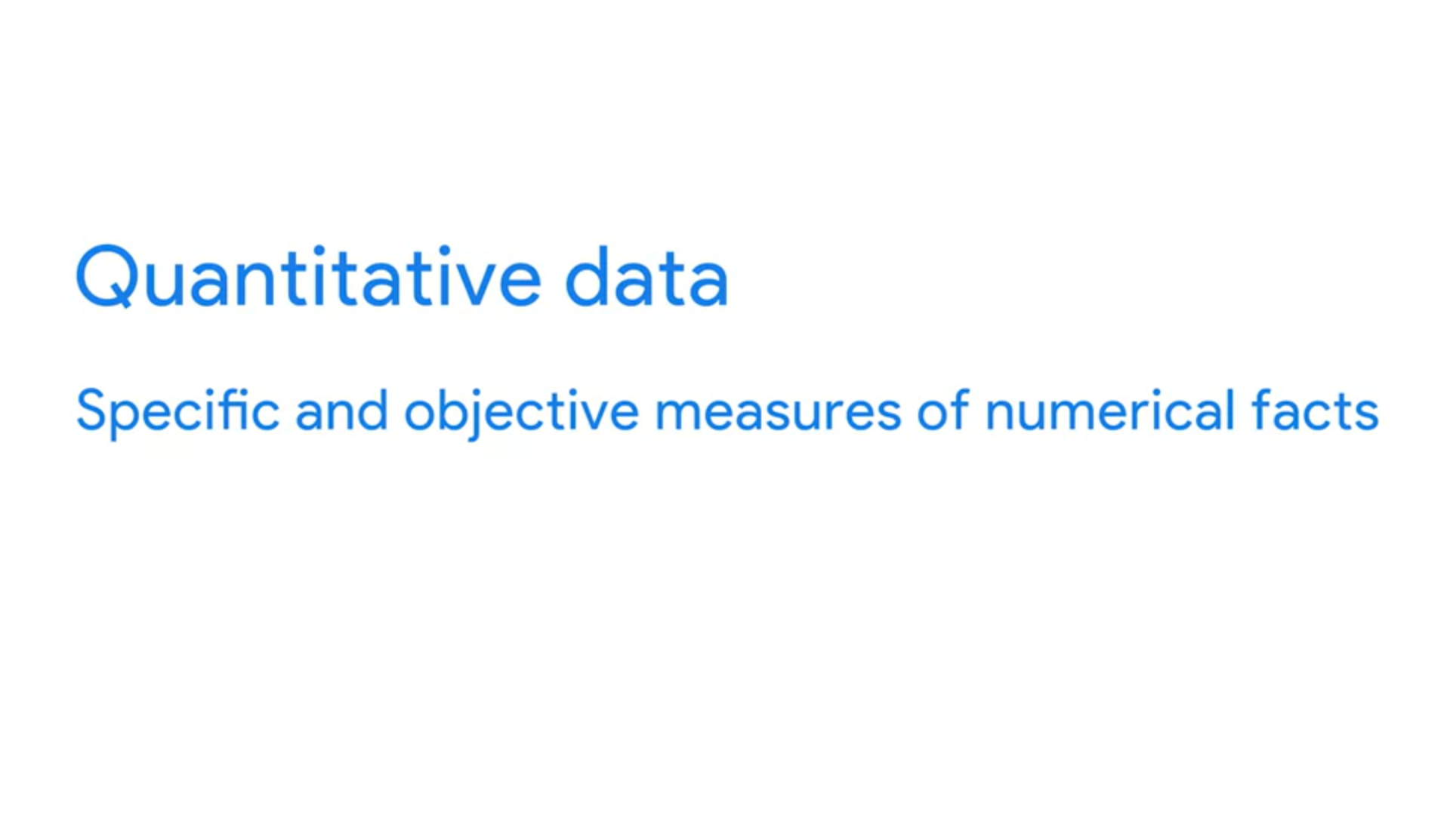



**Qualitative data**

**Qualitative data** describes qualities or characteristics. It is collected using questionnaires, interviews, or observation, and frequently appears in narrative form. For example, it could be notes taken during a focus group on the quality of the food at Cafe Mac, or responses from an open-ended questionnaire.

The hair colors of players on a football team, the color of cars in a parking lot, the letter grades of students in a classroom, the types of coins in a jar, and the shape of candies in a variety pack are all **examples of qualitative data** so long as a particular number is not assigned to any of these descriptions.

